Test Report
  UMGC Fall 2020 | Benjamin Fetterman, Benjamin Murray, Hanim Danur, James Cornelius, Robert Lee  SWEN 670

Project Plan Approvals
Name | Signature | Date
Approved by:
Dr. Mir Assadullah
Approved by:
"Stakeholder"
Approved by:  "Project Manager" | Robert Lee | 11/3/2020

Revision History
Revision | Date | Name | Description of Change(s)
1.0 | 11/03/2020 | Robert Lee | Initial Release

Table of Contents
1.0 Introduction 5
1.1 Purpose 5
1.2 Intended Audience 5
1.3 Technical Project Stakeholders 5
2.0 Overview of Test Results 5
3.0 Test Summary 6
3.1 Detailed Test Results 6
4.0 Subsystem Test 7
4.1 Chatbot Greeting 7
4.2 Chatbot Zoning/Permit Links 8
4.3 Chatbot Application Links 9
4.4 Chatbot Retrieve Regs 10
4.5 Chatbot Retrieve Standards 11
4.6 Chatbot Retrieve Permits Applicable to Zoning Statutes 13
4.7 Chatbot GIS Map Layer Integration 15
4.8 Chatbot Address Requirements 17
4.9 Address Validation 19
4.10 Chatbot Other Information 20
4.11 Chatbot Help 21
4.12 Retrieve Permit Unit Test 22
5.0 Test Execution Findings 23
5.1 Metrics 23
5.2 SonarQube Overview 23
5.3 Selenium Overview 24
5.4 JUnit Overview 24
6.0 Exit Criteria 25
Appendix A: Acronyms and Abbreviations 26
Appendix B: References 27

List of Tables
Table 1 Stakeholders 5
Table 2 Testing Responsibilities 6
Table 3 Schedule for Test Tasks 6
Table 4 Test Report 7
Table 5 Test-1.1 Chatbot Greeting 7
Table 6 Test-2.1 Chatbot Zoning/Permit Links 8
Table 7 Test-2.2 Chatbot Application Links 9
Table 8 Test-2.3 Chatbot Retrieve Regs 10
Table 9 Test-2.4 Chatbot Retrieve Standards 11
Table 10 Test-3.1 Chatbot Retrieve Permits Applicable to Zoning Statues 13
Table 11 Test-3.2 Chatbot GIS Map Layer Integration 15
Table 12 Test-4.1 Chatbot Address Requirements 17
Table 13 Test 4.2 Address Validation 19
Table 14 Test-5.2 Chatbot Help 21
Table 15 Overall Results of Selenium Tests 24
Table 16 Overall Results of JUnit Unit Tests 25

List of Figures
Figure 1 SonarQube Report 23

- Introduction
This document contains information pertaining to the testing activities of the UMGC chatbot application. The document contains the overview of test results, test summary, subsystem tests, and test execution findings.

Purpose
The purpose of this document is to explain and detail the variety of tests and their outcomes that were undertaken to ensure the viability of the UMGC chatbot application. This document details the results and findings of the tests.

Intended Audience
The intended audience for this guide are the developers and other project stakeholders who undertake supporting the UMGC chatbot application. This document will make them aware of tests that must be passed in order for the UMGC chatbot to function properly. If any change are made in the future, these tests should be run in order to ensure that such changes do not break the functionality of the UMGC City Chatbot.

Technical Project Stakeholders
Table 1 Stakeholders
Name | E-mail address | Role
Professor Assadullah | mir.assadullah@faculty.umgc.edu | Stakeholder
Robert Lee | rlee97@student.umgc.edu | Project Manager
Benjamin Fetterman | bfetterman2@student.umgc.edu | Developer
Benjamin Murray | bmurray19@student.umgc.edu | Developer
Hanim Danur | hdanur@student.umgc.edu | Developer
James Cornelius | jcornelius10@student.umgc.edu | Developer
Glenn Goodlett | ggoodlett1@student.umgc.edu | DevOps
Dustin Emerson | demerson2@student.umgc.edu | DevOps
- Overview of Test Results
The test for the City Chatbot application were performed as per the Test Plan and covered the entirety of the SRS that was established at the beginning of the project. The following roles were assigned to team members in accordance with the testing plan Additionally the below schedule was used to guide the test through the testing cycle to ensure all functional test were captured in testing. In addition to the outlined plan below, all JUnit test were complete and reviewed at the time of code submission to its respective repository.

Table 2 Testing Responsibilities
Position | Team Member | Responsibilities
Testing Lead | Rob Lee | Writing and executing functional test. Signs off on pass-fail and severity criteria. Submits reports.
Quality Lead | Ben Murray | Witnessing and validating testing. Confirming pass-fail criteria. Determines status of testing and resumption criteria.
Testing Team | Benjamin Fetterman  Hanim Danur  James Cornelius  Ben Murray  Robert Lee | Responsible for conducting testing.

Table 3 Schedule for Test Tasks
Due Date | Task | Comment
09/29/2020 | Test plan generated | Submit to project stakeholder for approval.
09/29/2020 | Testing specifications documented and delivered to testing team | Included in this document
10/09/2020 | Testing environment set up | Start with unit testing for developers and then system integration tests.
10/20/2020 | Milestone 3 Deliverable | Test plan updates and interim test reports delivered for Milestone 3
10/28/2020 | Complete specified tests | Complete tests by the end of the final development sprint.
11/03/2020 | Defect analysis and test summary report generated | Use severity list in section 7 of this document rating impact of defects
11/03/2020 | Test report delivered | Submit to project stakeholder for approval.

- Test Summary

Detailed Test Results
The following test were run to confirm the functional validity of the chatbot application and are identified in the below table with an indication of their status. All test passed and fulfilled the requirements established for this project. As such, this concludes testing for this project with no major bugs or defects found at this time.

Table 4 Test Report
Test ID | Test Name | Functional Requirement ID
Test-1.1 | Chatbot Greeting | CH-2 | PASSED
Test-2.1 | Chatbot Zoning/Permit Links | CH-3 | PASSED
Test-2.2 | Chatbot Application Links | CH-4 | PASSED
Test-2.3 | Chatbot Retrieve Regs | CH-5 | PASSED
Test-2.4 | Chatbot Retrieve Standards | CH-6 | PASSED
Test-3.1 | Chatbot Retrieve Permits Applicable to Zoning Statues | CH-7 | PASSED
Test-3.2 | Chatbot GIS Map Layer Integration | CH-8 | PASSED
Test-4.1 | Chatbot Address Requirements | CH-9 | PASSED
Test-4.2 | Address Validation | CH-10 | PASSED
Test-5.1 | Chatbot Other Information | CH-11 | PASSED
Test-5.2 | Chatbot Help | CH-13 | PASSED
Test-6.1 | Retrieve Permit | CH-7 | PASSED

- Subsystem Test
All test for this section, with the exception of the specified JUnit test, were complete using Selenium testing plugin. The testing was conducted by the Testing Lead and Verified by the Quality Lead once the final code release had been completed on 10/27/2020. Testing was conducted and verified on 10/28/2020 in accordance with the above schedule.

Chatbot Greeting
Table 5 Test-1.1 Chatbot Greeting
Title | Test Results
Test ID | Test-1.1
Test Name | Chatbot Greeting
Description | This functional requirement was to ensure that the chatbot would greet the user with each opening and ensure they are aware of the uses for the chatbot.
Pictures |   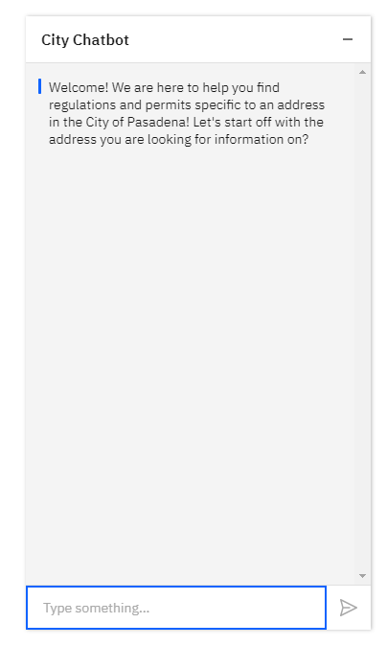
Selenium Test | PASSED

Chatbot Zoning/Permit Links
Table 6 Test-2.1 Chatbot Zoning/Permit Links
Title | Test Results
Test ID | Test-2.1
Test Name | Chatbot Zoning/Permit Links
Description | This functional requirement ensures that a link is returned to the user as requested when the correct information is given.
Pictures | 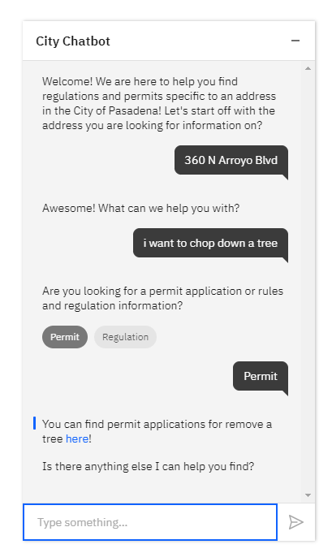
Selenium Test | PASSED

Chatbot Application Links
Table 7 Test-2.2 Chatbot Application Links
Title | Test Results
Test ID | Test-2.2
Test Name | Chatbot Application Links
Description | This functional requirement ensures that a link is returned to the user as requested when the correct information is given.
Pictures | 
Selenium Test | PASSED

Chatbot Retrieve Regs
Table 8 Test-2.3 Chatbot Retrieve Regs
Title | Test Results
Test ID | Test-2.3
Test Name | Chatbot Retrieve Regs
Description | This functional requirement ensures that a link is returned to the user as requested when the correct information is given.
Pictures | 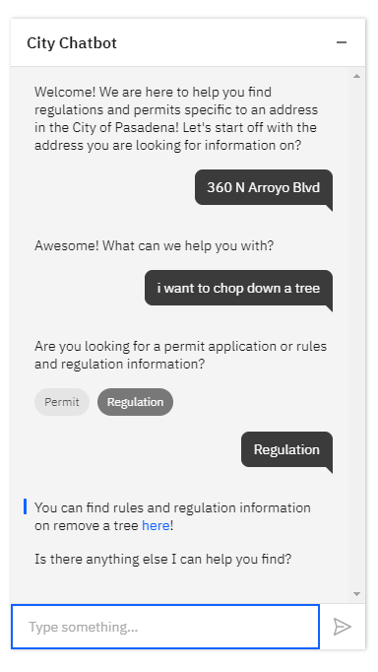
Selenium Test | PASSED

Chatbot Retrieve Standards
Table 9 Test-2.4 Chatbot Retrieve Standards
Title | Test Results
Test ID | Test-2.4
Test Name | Chatbot Retrieve Standards
Description | This functional requirement ensures that a link is returned to the user as requested when the correct information is given.
Pictures | Single standard:  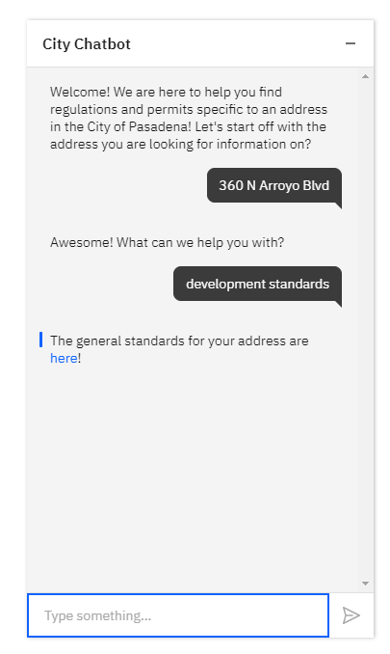  More than one standard:  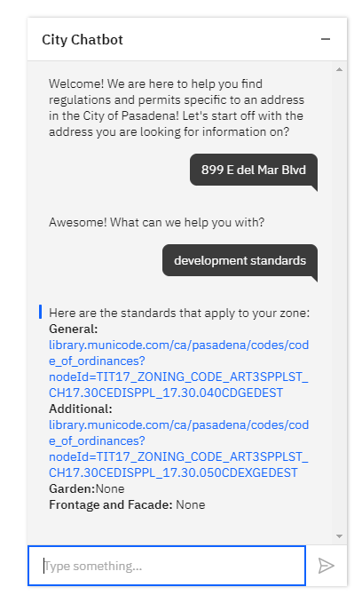
Selenium Test | PASSED

Chatbot Retrieve Permits Applicable to Zoning Statutes
Table 10 Test-3.1 Chatbot Retrieve Permits Applicable to Zoning Statues
Title | Test Results
Test ID | Test-3.1
Test Name | Chatbot Retrieve Permits Applicable to Zoning Statues
Description | This test is confirmed by searching for development standards with an address and confirming the address returns the correct zone standards.
Pictures | Chatbot:  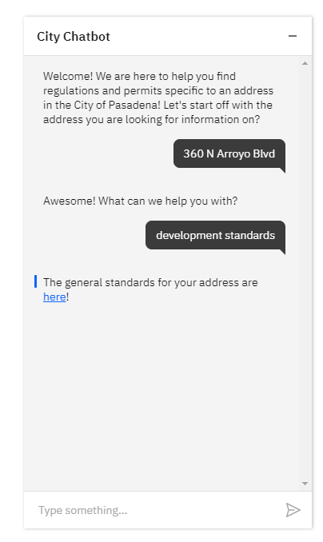  Returned Zone Standard:  https://library.municode.com/ca/pasadena/codes/code_of_ordinances?nodeId=TIT17_ZONING_CODE_ART2ZODIALLAUSZOECST_CH17.26SPPUZODI_17.26.040SPPUDIGEDEST  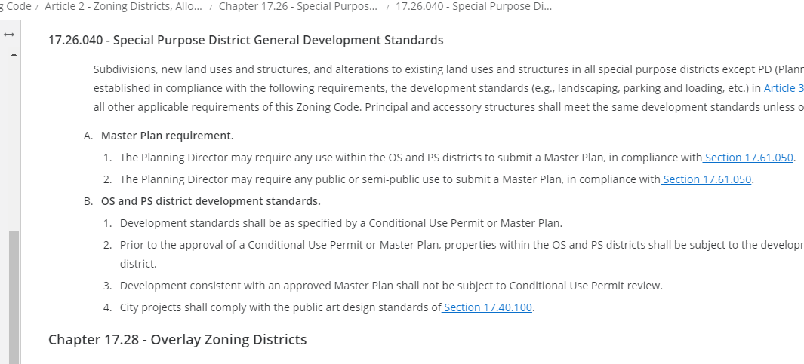  Confirmation of city Zone:  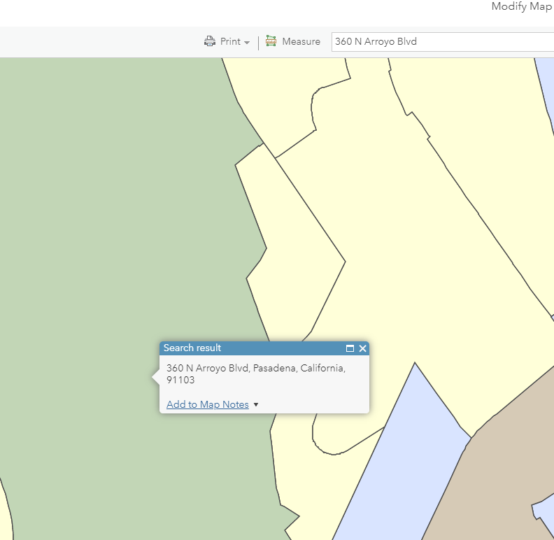  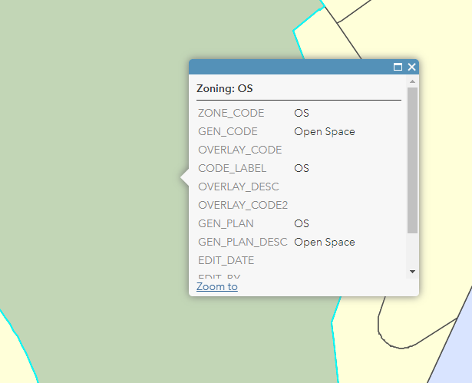
Selenium Test | NA

Chatbot GIS Map Layer Integration
Table 11 Test-3.2 Chatbot GIS Map Layer Integration
Title | Test Results
Test ID | Test-3.2
Test Name | Chatbot GIS Map Layer Integration
Description | This test is confirmed by searching for development standards with an address and confirming the address returns the correct zone standards.
Pictures | Chatbot:    Returned Zone Standard:  https://library.municode.com/ca/pasadena/codes/code_of_ordinances?nodeId=TIT17_ZONING_CODE_ART2ZODIALLAUSZOECST_CH17.26SPPUZODI_17.26.040SPPUDIGEDEST    Confirmation of city Zone:    
Selenium Test | NA

Chatbot Address Requirements
Table 12 Test-4.1 Chatbot Address Requirements
Title | Test Results
Test ID | Test-4.1
Test Name | Chatbot Address Requirements
Description | This functional requirement is used to ensure the chatbot request an address for each transaction so accurate information can be returned to the user.
Pictures | Permit address required  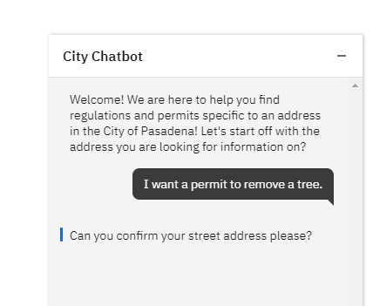  Development standards address required  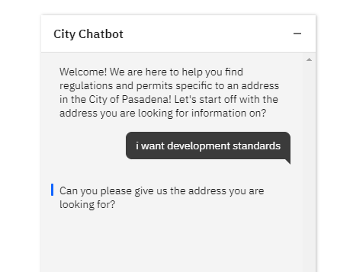
Selenium Test | PASSED

Address Validation
Table 13 Test 4.2 Address Validation
Title | Test Results
Test ID | Test-4.2
Test Name | Address Validation
Description | This functional requirement is used to determine if a city address is recognized by the chatbot in order to process request. Additionally, it test to ensure a bad address prompts the user to try again.
Pictures | Bad Address Verification  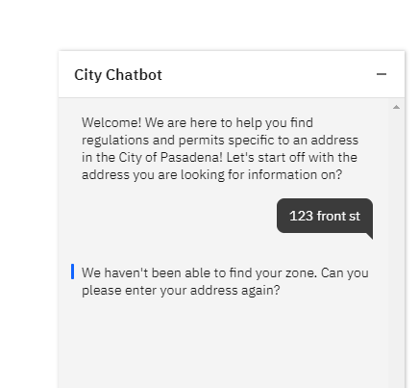  Good Address Verification  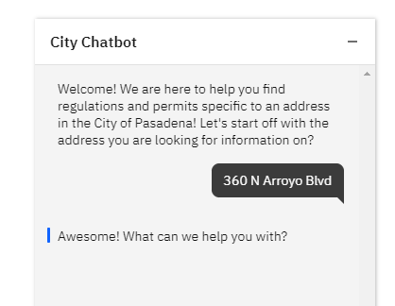
Selenium Test | PASSED

Chatbot Other Information
Title | Test Results
Test ID | Test-4.2
Test Name | Chatbot Other Information
Description | This functional requirement is used to provide the user with an additional place to look for information if the Chatbot is unable to answer their question.
Pictures | 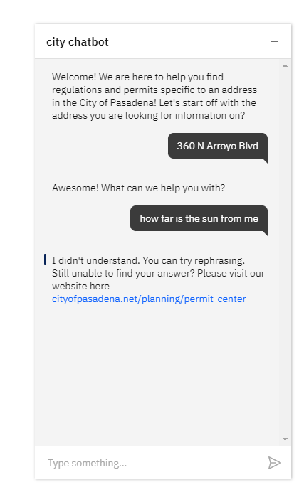
Selenium Test | PASSED

Chatbot Help
Table 14 Test-5.2 Chatbot Help
Title | Test Results
Test ID | Test-5.2
Test Name | Chatbot Help
Description | The functional requirement should return the proper contact information for a user that request contact information.
Pictures | 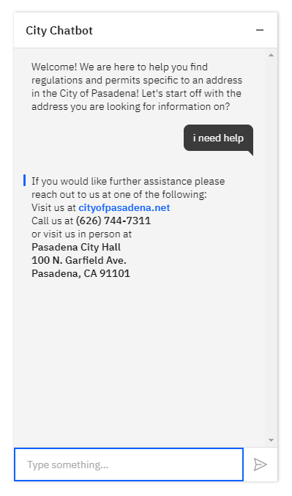
Selenium Test | PASSED

Retrieve Permit Unit Test
This is one of the unit test that has been developed for the REST API. It is representative of all of the unit tests. The other unit tests can be provided upon request.
Table 15 Test-6.1 Retrieve Permit
Title | Test Results
Test ID | Test-6.1
Test Name | Retrieve Permit
Description | The retrieveInformation method in the ProcessRequest should return the correct URL for the given type, action, object, and zone ID.
Pictures | 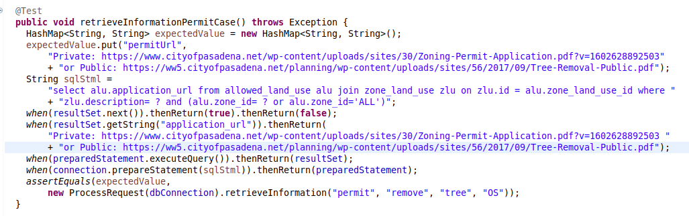
Junit Test | PASSED

- Test Execution Findings

Metrics
Test metrics are essential for assessing the functionality of an application in relation to what its requirements are. Metrics can help establish a baseline of where the system is at and reveal areas that need to be worked on. For this project, test metrics come from SonarQube analysis scans and from Selenium test results.

SonarQube Overview
SonarQube is a software application for performing code scans in order to find errors, vulnerabilities, and bad practices in a code base (SonarQube, n.d.). The UMGC SWEN 670 DevOps team has set up SonarQube to run a code scan each time that a build for the Spring IO master branch is started. Once a scan is complete, a report is published that contains the metrics on errors, vulnerabilities, and bad practices along with many more categories. Below is a screenshot that displays the results from the final SonarQube scan on the Spring IO master branch.

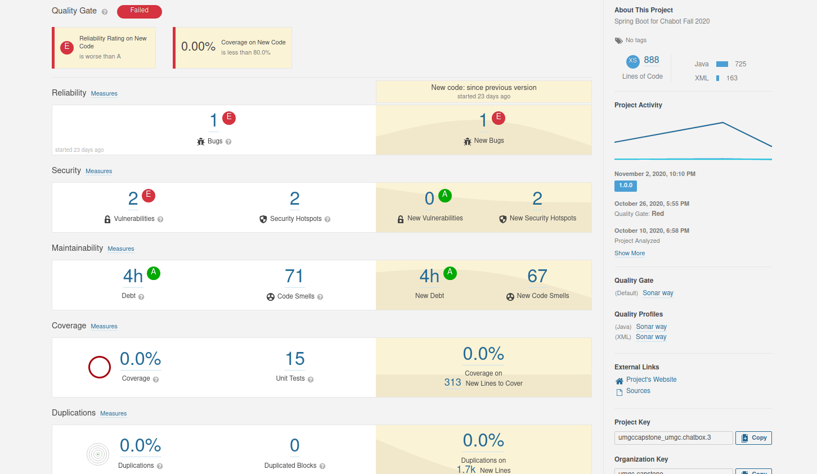
Figure 1 SonarQube Report

Selenium Overview
Selenium is a collection of free tools for creating automated tests that run on a web browser (Selenium, n.d.). The test cases listed in section 4 of this document were created using Selenium IDE. Selenium IDE is a browser extension that enables for quick and easy development of Selenium tests. Below are the overall results from running the Selenium tests.
Table 15 Overall Results of Selenium Tests
Item | Result
Features to be Tested | 11
Features that Passed Testing | 11
Features that Failed Testing | 0

There were no test cases that failed and thus no findings to report.

JUnit Overview
Junit is a testing framework for writing unit tests in Java (JUnit, n.d.). Unit tests are small tests that test whether a single piece of code functions as expected (Software Testing Fundamentals, n.d.). For this project, unit tests were only created for the Spring IO REST API application. Because unit tests are meant to be small simple tests, the unit tests for this project do not reach out to the MySQL database nor to the MapQuest Geocode API. Instead, the Mockito framework is used to return mock data for any unit tests that need to reach out to either the MySQL database or to the MapQuest Geocode API. Below are the overall results for running the JUnit unit tests.
Table 16 Overall Results of JUnit Unit Tests
Item | Result
Unit Tests to Run | 31
Unit Tests that Passed | 31
Unit Tests that Failed | 0

There were no unit tests that failed and thus no findings to report.
- Exit Criteria
All exit criteria for this test have been met and testing has been concluded. No bugs or defects have been identified or require addition inspection. The testing of the bot has concluded the successful completion of the established test plan and encompasses all requirements for the project as established in the SRS.

- Acronyms and Abbreviations
Acronym/Abbreviation | Definition/References
AI | Artificial Intelligence – An application that aims to mimic human intelligence.
API | Application Programming Interface
CH | Chatbot
CU | Conditional Use Permit
DevSecOps | Development, Security and Operations – Group of developers responsible for the deployment and security of an application.
ECUP | Expressive Use Permit
EPSP | East Pasadena Specific Plan
ETL | Extract, transfer, and load
FGSP | Fair Oaks/Orange Grove Specific Plan
GIS | Geographical Information System – System for working with geographical data.
HTTP | Hyper Text Transfer Protocol – A network protocol for specifying how servers and clients communicate with each other.
IDE | Integrated Development Environment
KML | Keyhold Markup Language – A markup language for visualizing geographical data.
LASP | Lincoln Avenue Specific Plan
MCUP | Minor Conditional Use Permit
MVC | Model-View-Controller
REST API | Representation State Transfer – An API for interacting with data.
SRS | Software Requirements Specification
UI | User Interface – The part of the application that users use to interact with the application.
URL | Uniform Resource Locator
WSL | Windows Subsystem for Linux

- References
JUnit. (n.d.). JUnit. Retrieved from https://junit.org/junit4/
Selenium. (n.d.). The Selenium Browser Automation Project. Retrieved from https://www.selenium.dev/documentation/en/
Software Testing Fundamenstals. (n.d.). Unit Testing. Retrieved from https://softwaretestingfundamentals.com/unit-testing/
SonarQube. (n.d.). SonarQube Documentation. Retrieved from https://docs.sonarqube.org/latest/

